End-to-End Serverless Data Pipeline with AWS and Spotify API

🌟 Introduction
Data engineering is about building scalable, automated, and analytics-ready pipelines. In this project, I designed a Spotify-to-Athena pipeline using AWS services, designed to extract, transform, and load (ETL) data in a fully serverless way.
This article documents every stage of the pipeline, the AWS services used, and the lessons learned.
🏗️ Architecture Diagram
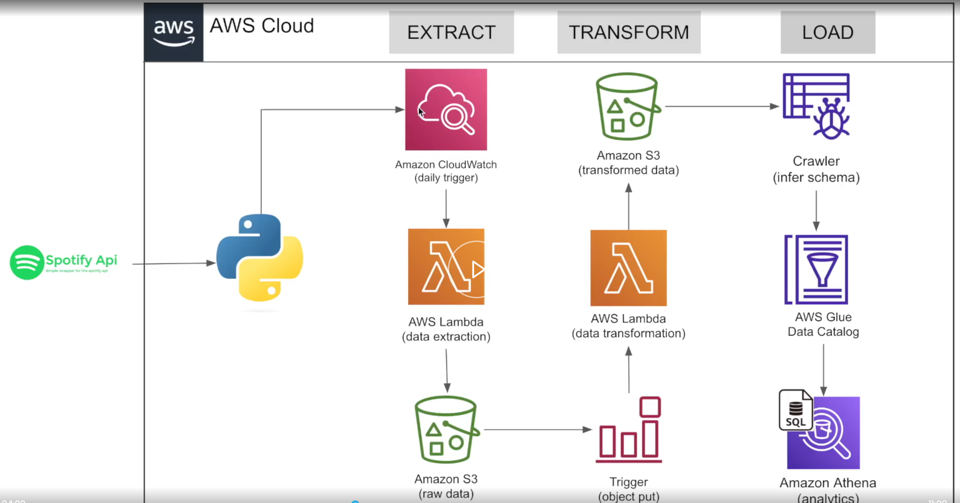

🔹 Stage 1: Extract
- Spotify API → Source of raw music data.
- Python Script → Handles API calls and data formatting.
- Amazon CloudWatch → Triggers the pipeline daily.
- AWS Lambda (Extraction Function) → Executes the script, pulls data, and stores raw JSON.
- Amazon S3 (Raw Zone) → Durable storage for raw data.

code:
import json
import os
import spotipy
from spotipy.oauth2 import SpotifyClientCredentials
import boto3
from datetime import datetime

# Main entry point for AWS Lambda
def lambda_handler(event, context):

# Read Spotify API credentials from environment variables
# (Best practice: never hardcode secrets in code)
cilent_id = os.environ.get('client_id')
client_secret = os.environ.get('client_secret')

# Authenticate with Spotify using Client Credentials flow
client_credentials_manager = SpotifyClientCredentials(
client_id=cilent_id,
client_secret=client_secret
)
sp = spotipy.Spotify(client_credentials_manager=client_credentials_manager)

# Fetch playlists owned by the Spotify account "spotify"
playlists = sp.user_playlists('spotify')

# Define a specific playlist link (Spotify Top 50 Global in this case)
playlist_link = "https://open.spotify.com/playlist/37i9dQZEVXbNG2KDcFcKOF?si=1333723a6eff4b7f"

# Extract the playlist ID (URI) from the link
playlist_URI = playlist_link.split("/")[-1].split("?")[0]

# Fetch all tracks from the playlist as JSON data
spotify_data = sp.playlist_tracks(playlist_URI)

# Create an S3 client using boto3
cilent = boto3.client('s3')

# Generate a unique filename with timestamp for each data dump
filename = "spotify_raw_" + str(datetime.now()) + ".json"

# Upload the playlist data to S3
# Bucket: spotify-etl-project-darshil
# Key: raw_data/to_processed/<filename>
# Body: JSON string of the playlist data
cilent.put_object(
Bucket="spotify-etl-project-darshil",
Key="raw_data/to_processed/" + filename,
Body=json.dumps(spotify_data)
)

🔹 Stage 2: Transform
- S3 Trigger (ObjectCreated Event) → Automatically starts transformation when new data arrives.
- AWS Lambda (Transformation Function) → Cleans, flattens, and structures the data.
- Amazon S3 (Processed Zone) → Stores transformed, analytics-ready data.

Code:
import json
import boto3
from datetime import datetime
from io import StringIO
import pandas as pd

# -----------------------------
# Helper function: Extract album details
# -----------------------------
def album(data):
album_list = []
for row in data['items']:
# Extract album attributes from each track
album_id = row['track']['album']['id']
album_name = row['track']['album']['name']
album_release_date = row['track']['album']['release_date']
album_total_tracks = row['track']['album']['total_tracks']
album_url = row['track']['album']['external_urls']['spotify']

# Build dictionary for album
album_element = {
'album_id': album_id,
'name': album_name,
'release_date': album_release_date,
'total_tracks': album_total_tracks,
'url': album_url
}
album_list.append(album_element)
return album_list

# -----------------------------
# Helper function: Extract artist details
# -----------------------------
def artist(data):
artist_list = []
for row in data['items']:
for key, value in row.items():
if key == "track":
# Each track can have multiple artists
for artist in value['artists']:
artist_dict = {
'artist_id': artist['id'],
'artist_name': artist['name'],
'external_url': artist['href']
}
artist_list.append(artist_dict)
return artist_list

# -----------------------------
# Helper function: Extract song details
# -----------------------------
def songs(data):
song_list = []
for row in data['items']:
# Extract song attributes
song_id = row['track']['id']
song_name = row['track']['name']
song_duration = row['track']['duration_ms']
song_url = row['track']['external_urls']['spotify']
song_popularity = row['track']['popularity']
song_added = row['added_at']
album_id = row['track']['album']['id']
artist_id = row['track']['album']['artists'][0]['id']

# Build dictionary for song
song_element = {
'song_id': song_id,
'song_name': song_name,
'duration_ms': song_duration,
'url': song_url,
'popularity': song_popularity,
'song_added': song_added,
'album_id': album_id,
'artist_id': artist_id
}
song_list.append(song_element)

return song_list

# -----------------------------
# Main Lambda handler
# -----------------------------
def lambda_handler(event, context):
# Connect to S3
s3 = boto3.client('s3')
Bucket = "spotify-etl-project-darshil"
Key = "raw_data/to_processed/"

spotify_data = []
spotify_keys = []

# List all raw JSON files in the bucket
for file in s3.list_objects(Bucket=Bucket, Prefix=Key)['Contents']:
file_key = file['Key']
if file_key.split('.')[-1] == "json":
# Read JSON file from S3
response = s3.get_object(Bucket=Bucket, Key=file_key)
content = response['Body']
jsonObject = json.loads(content.read())

# Store data and file key for processing
spotify_data.append(jsonObject)
spotify_keys.append(file_key)

# Process each JSON file
for data in spotify_data:
# Extract albums, artists, and songs
album_list = album(data)
artist_list = artist(data)
song_list = songs(data)

# Convert lists into Pandas DataFrames
album_df = pd.DataFrame.from_dict(album_list).drop_duplicates(subset=['album_id'])
artist_df = pd.DataFrame.from_dict(artist_list).drop_duplicates(subset=['artist_id'])
song_df = pd.DataFrame.from_dict(song_list)

# Convert date fields into proper datetime format
album_df['release_date'] = pd.to_datetime(album_df['release_date'])
song_df['song_added'] = pd.to_datetime(song_df['song_added'])

# -----------------------------
# Save transformed SONG data to S3
# -----------------------------
songs_key = "transformed_data/songs_data/songs_transformed_" + str(datetime.now()) + ".csv"
song_buffer = StringIO()
song_df.to_csv(song_buffer, index=False)
s3.put_object(Bucket=Bucket, Key=songs_key, Body=song_buffer.getvalue())

# -----------------------------
# Save transformed ALBUM data to S3
# -----------------------------
album_key = "transformed_data/album_data/album_transformed_" + str(datetime.now()) + ".csv"
album_buffer = StringIO()
album_df.to_csv(album_buffer, index=False)
s3.put_object(Bucket=Bucket, Key=album_key, Body=album_buffer.getvalue())

# -----------------------------
# Save transformed ARTIST data to S3
# -----------------------------
artist_key = "transformed_data/artist_data/artist_transformed_" + str(datetime.now()) + ".csv"
artist_buffer = StringIO()
artist_df.to_csv(artist_buffer, index=False)
s3.put_object(Bucket=Bucket, Key=artist_key, Body=artist_buffer.getvalue())

# -----------------------------
# Move raw files to 'processed' folder after transformation
# -----------------------------
s3_resource = boto3.resource('s3')
for key in spotify_keys:
copy_source = {'Bucket': Bucket, 'Key': key}
# Copy raw file to processed folder
s3_resource.meta.client.copy(copy_source, Bucket, 'raw_data/processed/' + key.split("/")[-1])
# Delete original raw file from 'to_processed'
s3_resource.Object(Bucket, key).delete()

🔹 Stage 3: Load
- AWS Glue Crawler → Infers schema from transformed data.
- AWS Glue Data Catalog → Central metadata repository.
- Amazon Athena → Enables SQL queries directly on S3 data.
⚙️ AWS Services

Amazon S3
- Scalable object storage with 11 nines durability.
- Stores raw and transformed data.
- Backbone for Athena queries.
- he script, pulls data, and stores raw JSON.
- Amazon S3 (Raw Zone): Durable storage for raw data.

🔹 AWS Lambda
What it is: Serverless compute service that runs code in response to events. Key Features:
- Event-Driven: Executes only when triggered (e.g., S3 upload, CloudWatch schedule).
- Automatic Scaling: Handles thousands of requests without manual provisioning.
- Pay-per-Use: Billed per millisecond of execution.
- Language Support: Python, Node.js, Java, and more. Use in your project:
- Extracts data from Spotify API and stores it in S3.
- Transforms raw JSON into structured format for analytics.

🔹 Amazon CloudWatch
What it is: Monitoring and observability service for AWS resources and applications. Key Features:
- Metrics: Collects CPU, memory, and custom application metrics.
- Logs: Centralized log storage for debugging and auditing.
- Alarms: Automated alerts when thresholds are breached.
- Events: Triggers actions (like Lambda) based on schedules or resource changes. Use in your project:
- Daily scheduled trigger for Lambda extraction function.
- Can be extended to monitor pipeline health and send alerts.
🔹 AWS Glue
What it is: Serverless data integration and ETL service. Key Features:
- Glue Crawler: Automatically discovers schema from data in S3.
- Glue Data Catalog: Central metadata repository for datasets.
- ETL Jobs: Can run transformations at scale (though you used Lambda for lightweight transforms).
- Serverless: No infrastructure management, pay only for jobs run. Use in your project:
- Crawler infers schema from transformed data.
- Data Catalog enables Athena to query datasets seamlessly.
🔹 Amazon Athena
What it is: Serverless interactive query service for analyzing data in S3 using SQL. Key Features:
- No Infrastructure: No servers to manage, queries run directly on S3.
- Standard SQL: Easy adoption for analysts and engineers.
- Scalability: Executes queries in parallel for fast results.
- Cost Efficiency: Pay only for data scanned per query. Use in your project:
- Runs SQL queries on Spotify data stored in S3.
- Enables analytics without needing a data warehouse.

📚 What I Learned
- Designing production-grade pipelines with AWS.
- Leveraging Lambda triggers for automation.
- Building analytics-ready datasets with Glue + Athena.
- Thinking about monitoring, reliability, and scalability from day one.

🚀 Conclusion
This project demonstrates how AWS services can be combined to build a cost-effective, scalable, and automated pipeline. It’s a strong foundation for extending into streaming ingestion, dashboards, or advanced analytics.

